# 1.On fusing the latent deep CNN feature for image classification

* [Xueliang Liu](https://link.springer.com/article/10.1007/s11280-018-0600-3#auth-1),
* [Rongjie Zhang](https://link.springer.com/article/10.1007/s11280-018-0600-3#auth-2),
* [Zhijun Meng](https://link.springer.com/article/10.1007/s11280-018-0600-3#auth-3),
* [Richang Hong](https://link.springer.com/article/10.1007/s11280-018-0600-3#auth-4) &
* [Guangcan Liu](https://link.springer.com/article/10.1007/s11280-018-0600-3#auth-5)

[*World Wide Web*](https://link.springer.com/journal/11280)

volume

## Abstract

Image classification, which aims at assigning a semantic category to images, has been extensively studied during the past few years. More recently, convolution neural network arises and has achieved very promising achievement. Compared with traditional feature extraction techniques (e.g., SIFT, HOG, GIST), the convolutional neural network can extract features from image automatically and does not need hand designed features. However, how to further improve the classification algorithm is still challenging in academic research. The latest research on CNN shows that the features extracted from middle layers is representative, which shows a possible way to improve the classification accuracy. Based on the observation, in this paper, we propose a method to fuse the latent features extracted from the middle layers in a CNN to train a more robust classifier. First, we utilize the pretrained CNN models to extract visual features from middle layer. Then, we use supervised learning method to train classifiers for each feature respectively. Finally, we use the late fusion strategy to combine the prediction of these classifiers. We evaluate the proposal with different classification methods under some several images benchmarks, and the results demonstrate that the proposed method can improve the performance effectively.

* [Published: 15 June 2018](https://link.springer.com/article/10.1007/s11280-018-0600-3#article-info)

2..**A Deep CNN-LSTM Model for Particulate Matter (PM2.5) Forecasting in Smart Cities**

by [**Chiou-Jye Huang**](https://sciprofiles.com/profile/197963) 1 and[**Ping-Huan Kuo**](https://sciprofiles.com/profile/362642) 2,*

1

School of Electrical Engineering and Automation, Jiangxi University of Science and Technology, Ganzhou 341000, China

2

Computer and Intelligent Robot Program for Bachelor Degree, National Pingtung University, Pingtung 90004, Taiwan

*

Author to whom correspondence should be addressed.

*Sensors* **2018**, *18*(7), 2220; [**https://doi.org/10.3390/s18072220**](https://doi.org/10.3390/s18072220)

**Received: 31 May 2018 / Revised: 7 July 2018 / Accepted: 8 July 2018 / Published: 10 July 2018**

(This article belongs to the Special Issue [**Intelligent Systems for Exploiting Real Sensed Data in Smart City Applications**](https://www.mdpi.com/journal/sensors/special_issues/real_sensed))

[**View Full-Text**](https://www.mdpi.com/1424-8220/18/7/2220/htm) [**Download PDF**](https://www.mdpi.com/1424-8220/18/7/2220/pdf) [**Browse Figures**](https://www.mdpi.com/1424-8220/18/7/2220#) [**Cite This Paper**](https://www.mdpi.com/1424-8220/18/7/2220#cite)

## **Abstract**

In modern society, air pollution is an important topic as this pollution exerts a critically bad influence on human health and the environment. Among air pollutants, Particulate Matter (PM2.5) consists of suspended particles with a diameter equal to or less than 2.5 μm. Sources of PM2.5 can be coal-fired power generation, smoke, or dusts. These suspended particles in the air can damage the respiratory and cardiovascular systems of the human body, which may further lead to other diseases such as asthma, lung cancer, or cardiovascular diseases. To monitor and estimate the PM2.5 concentration, Convolutional Neural Network (CNN) and Long Short-Term Memory (LSTM) are combined and applied to the PM2.5 forecasting system. To compare the overall performance of each algorithm, four measurement indexes, Mean Absolute Error (MAE), Root Mean Square Error (RMSE) Pearson correlation coefficient and Index of Agreement (IA) are applied to the experiments in this paper. Compared with other machine learning methods, the experimental results showed that the forecasting accuracy of the proposed CNN-LSTM model (APNet) is verified to be the highest in this paper. For the CNN-LSTM model, its feasibility and practicability to forecast the PM2.5 concentration are also verified in this paper. The main contribution of this paper is to develop a deep neural network model that integrates the CNN and LSTM architectures, and through historical data such as cumulated hours of rain, cumulated wind speed and PM2.5 concentration. In the future, this study can also be applied to the prevention and control of PM2.5. [**View Full-Text**](https://www.mdpi.com/1424-8220/18/7/2220/htm)

*Keywords:* [**PM2.5 forecasting**](https://www.mdpi.com/search?q=PM2.5%20forecasting); [**deep learning**](https://www.mdpi.com/search?q=deep%20learning); [**big data analytics**](https://www.mdpi.com/search?q=big%20data%20analytics); [**CNN-LSTM model**](https://www.mdpi.com/search?q=CNN-LSTM%20model)

**[▼ Show Figures](https://www.mdpi.com/1424-8220/18/7/2220#)**

**[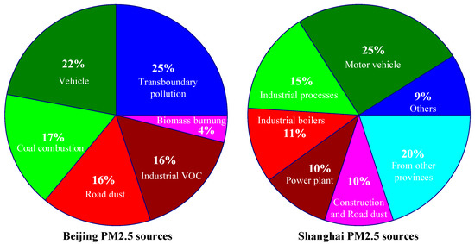](https://www.mdpi.com/1424-8220/18/7/2220#)**



Figure 1

This is an open access article distributed under the [**Creative Commons Attribution License**](https://creativecommons.org/licenses/by/4.0/) which permits unrestricted use, distribution, and reproduction in any medium, provided the original work is properly cited

Ref : <https://www.mdpi.com/1424-8220/18/7/2220/htm>

# **A survey of recent advances in CNN-based single image crowd counting and density estimation**

(Can be combined with coronavirus spread %)

## **Abstract**

Estimating count and density maps from crowd images has a wide range of applications such as video surveillance, traffic monitoring, public safety and urban planning. In addition, techniques developed for crowd counting can be applied to related tasks in other fields of study such as cell microscopy, vehicle counting and environmental survey. The task of crowd counting and density map estimation is riddled with many challenges such as occlusions, non-uniform density, intra-scene and inter-scene variations in scale and perspective. Nevertheless, over the last few years, crowd count analysis has evolved from earlier methods that are often limited to small variations in crowd density and scales to the current [state-of-the-art methods](https://www.sciencedirect.com/topics/engineering/state-of-the-art-method) that have developed the ability to perform successfully on a wide range of scenarios. The success of crowd counting methods in the recent years can be largely attributed to deep learning and publications of challenging datasets. In this paper, we provide a comprehensive survey of recent [Convolutional Neural Network](https://www.sciencedirect.com/topics/engineering/convolutional-neural-network) (CNN) based approaches that have demonstrated significant improvements over earlier methods that rely largely on hand-crafted representations. First, we briefly review the pioneering methods that use hand-crafted representations and then we delve in detail into the deep learning-based approaches and recently published datasets. Furthermore, we discuss the merits and drawbacks of existing CNN-based approaches and identify promising avenues of research in this rapidly evolving field.

# **Deep CNN Based Data-Driven Recognition of Cricket Batting Shots**

**Abstract:**

Cricket is one of the most played and watched sports, specially in the South Asian region. This paper deals with identifying and categorizing various batting shots from cricket videos. Proposed method is based on deep convolution neural networks. Results have been evaluated for both 2D convolution followed by recurrent network for processing sequence of video frames and 3D convolution network for capturing spatial and temporal features simultaneously. In order to train and evaluate models, dataset comprising of about 800 batting shot clips have been locally developed. Obtained models are able to recognize a shot being played with 90% accuracy. The distinction of such visually similar shots with this high accuracy is novel in literature and indicates the high implications of modern AI and deep learning in applications for detecting various cricket activities as well as for decision making purposes. The prepared dataset will be made publicly available for research community.

**Published in:** [2018 International Conference on Applied and Engineering Mathematics (ICAEM)](https://ieeexplore.ieee.org/xpl/conhome/8516561/proceeding)

**Date of Conference:** 4-5 Sept. 2018

**Date Added to IEEE *Xplore*:** 15 November 2018

**ISBN Information:**

**INSPEC Accession Number:** 18236230

**DOI:** [10.1109/ICAEM.2018.8536277](https://doi.org/10.1109/ICAEM.2018.8536277)

**Publisher:** IEEE

**Conference Location:** Taxila, Pakistan

# **Deep Learning for Natural Language Processing (NLP)  – using RNNs & CNNs**

### **Using CNNs for NLP tasks**

Traditionally, we think that a convolutional network (CNN) is a neural network that is specialized for processing a grid of values such as an image. And a recurrent neural network (RNN) is a neural network that is specialized for processing a sequence of values.

But more recently we’ve also started to apply CNNs to problems in Natural Language Processing and gotten some interesting results.

#### **Classification Tasks**

Since CNNs, unlike RNNs, can output only fixed sized vectors, the natural fit for them seem to be in the classification tasks such as Sentiment Analysis, Spam Detection or Topic Categorization.

In computer vision tasks, the filters used in CNNs slide over patches of an image whereas in NLP tasks, the filters slide over the sentence matrices, a few words at a time.

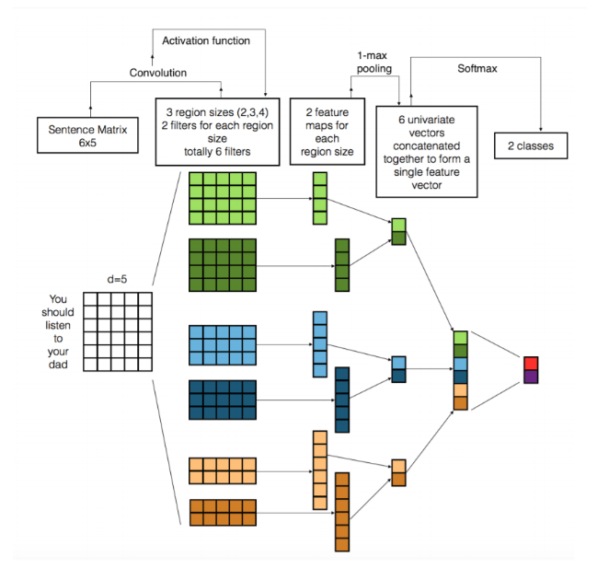

**The 1st layer shows 6 filters: 2 pass over 2 words at a time, another 2 filters pass over 3 words at a time and the last 2 filters pass over 4 words at a time. Source:** [**https://arxiv.org/pdf/1703.03091.pdf**](https://arxiv.org/pdf/1703.03091.pdf)

The learned filters of the first layer, capture features that are quite like the n-grams but represented in a more compact way.

A big argument for CNNs is that they are very fast. Convolutions are a central part of computer graphics and implemented on a hardware level on GPUs.

You should check out [this paper](https://arxiv.org/pdf/1703.03091.pdf) to get a summary of the various ways CNNs have been used for NLP tasks.

### **Generating Image Descriptions**

Remember how in the sequence-to-sequence models, the encoder creates a vector representation of the input data and the decoder takes that vector to generate a new sequence?

Now, what if we replaced the RNN in that encoder with a CNN?

This would give us a model that can take in an image and generate a sequence based on that image!

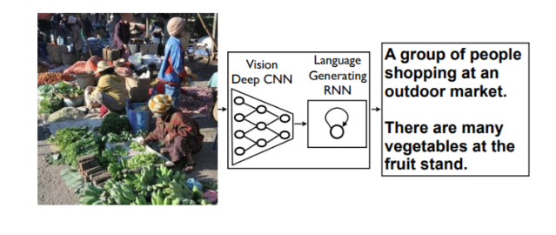

**We can then pass an image to our model and have it output a sentence that describes the image. Source:** [**https://www.cv-foundation.org/openaccess/content_cvpr_2015/papers/Vinyals_Show_and_Tell_2015_CVPR_paper.pdf**](https://www.cv-foundation.org/openaccess/content_cvpr_2015/papers/Vinyals_Show_and_Tell_2015_CVPR_paper.pdf)

Automatically describing the content of an image is a fundamental problem in artificial intelligence that connects computer vision and natural language processing. Being able to automatically describe the content of an image using properly formed English sentences is a very challenging task, but it could have great impact. For instance, it can assist visually impaired people better understand the content of images on the web. Automatically describing the content of an image is a fundamental problem in artificial intelligence that connects computer vision and natural language processing. Being able to automatically describe the content of an image using properly formed English sentences is a very challenging task, but it could have great impact. For instance, it can assist visually impaired people better understand the content of images on the web.

